Chapter 4:

Implementation

In this chapter, we are going to study the implementation strategies, coding standards of the project and some screenshots.

**4.3 Snapshots of project**

**Home page:**







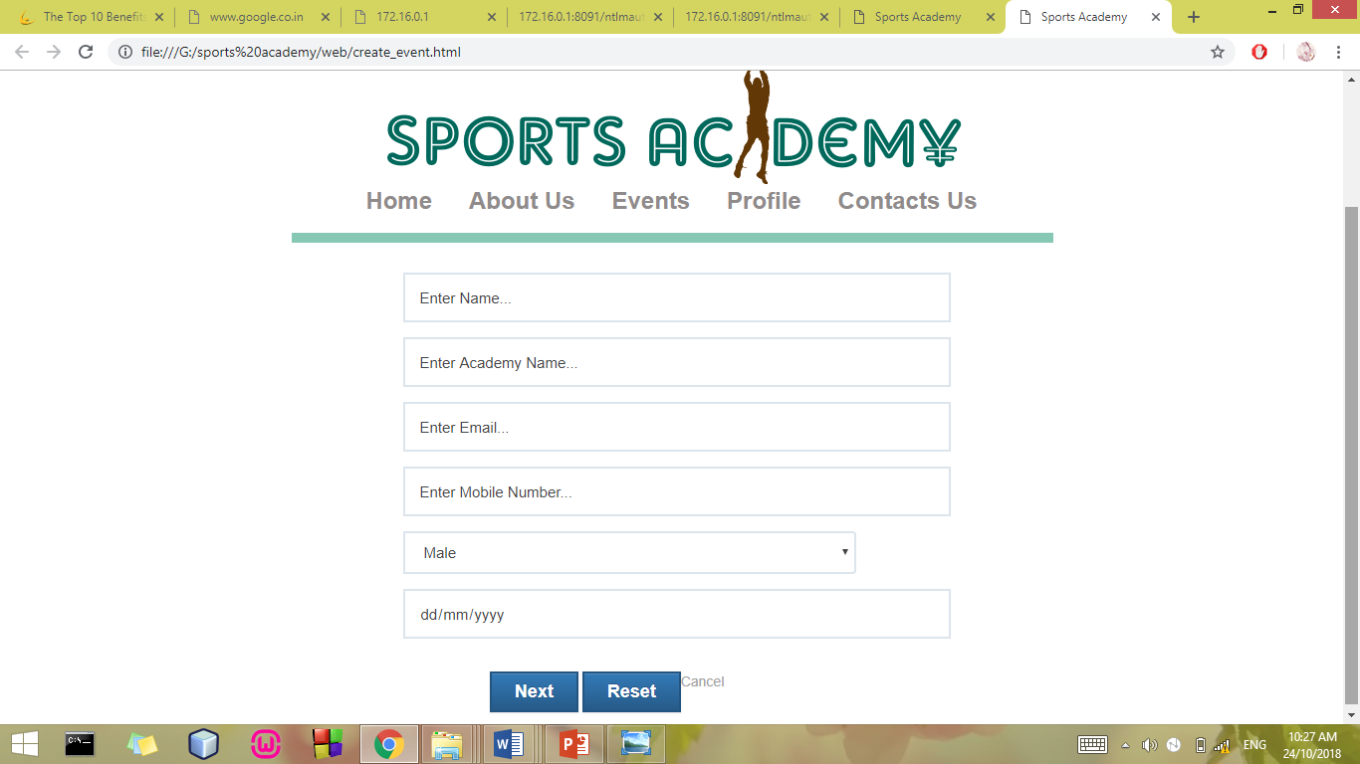

**Registration page:**

**Login page:**